What is Git?
Git is a version control system used for tracking changes in computer files. It is generally used for source code management in software development.
- Git is used to tracking changes in the source code
- The distributed version control tool is used for source code management
- It allows multiple developers to work together
- It supports non-linear development through its thousands of parallel branches

Features of Git
- Tracks history
- Free and open source
- Supports non-linear development
- Creates backups
- Scalable
- Supports collaboration
- Branching is easier
- Distributed development
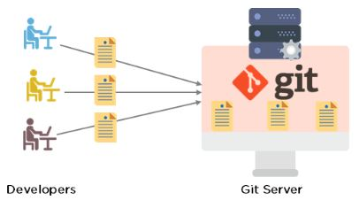

Git Workflow
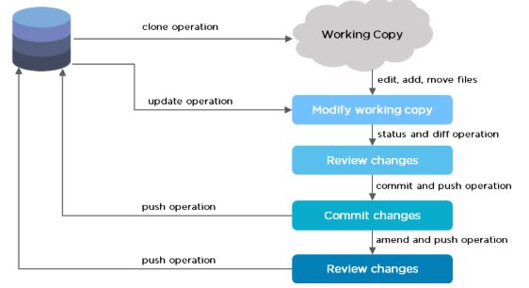
The Git workflow is divided into three states:
- Working directory - Modify files in your working directory
- Staging area (Index) - Stage the files and add snapshots of them to your staging area
- Git directory (Repository) - Perform a commit that stores the snapshots permanently to your Git directory. Checkout any existing version, make changes, stage them and commit.
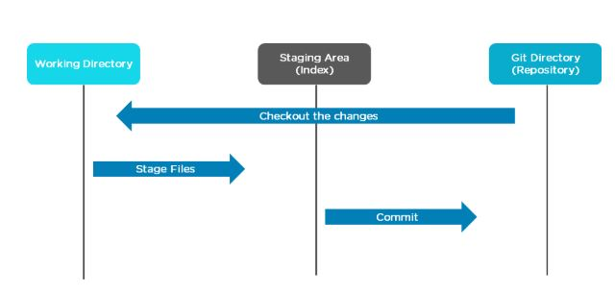

Branch in Git
Branch in Git is used to keep your changes until they are ready. You can do your work on a branch while the main branch (master) remains stable. After you are done with your work, you can merge it with the main office.
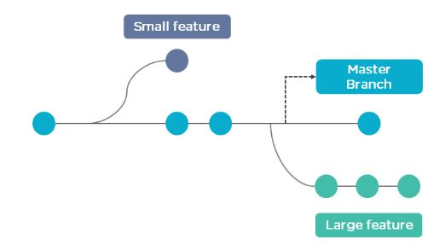
The above diagram shows there is a master branch. There are two separate branches called “small feature” and “large feature.” Once you are finished working with the two separate branches, you can merge them and create a master branch.

FREE GIT Training
Learn the basics of GITENROLL NOW
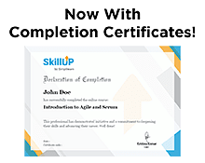

Commands in Git
- Create Repositories
git init
- Make Changes
add
commit
status
- Parallel Development
branch
merge
rebase
- Sync Repositories
push
pull
add origin

Command
- Check the version of Git.
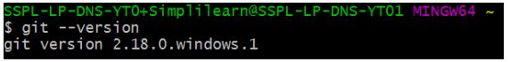
- Set up global config variables - If you are working with other developers, you need to know who is checking the code in and out, and to make the changes.
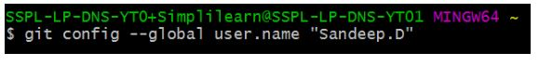
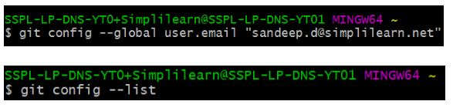
- If in case you need help, use the following commands:
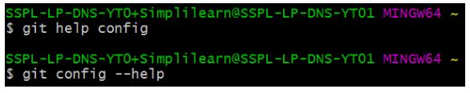
This will lead you to the Git help page on the browser, which will display the following:
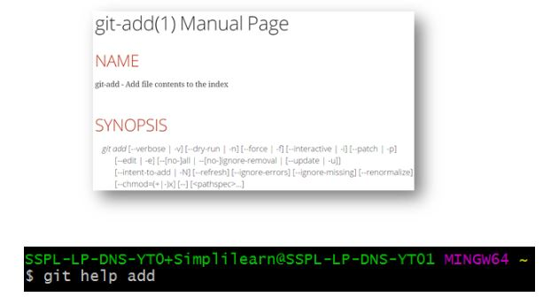

DevOps Certification Training Course
Gain expertise in the top DevOps toolsEXPLORE COURSE
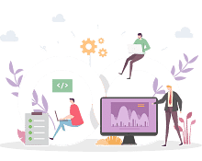
This will lead you to the Git help page on the browser, which will display the following:
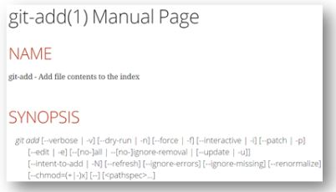
- Create a “test” repository in the local system.
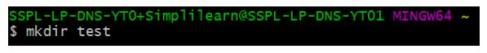
- Move to the test repository.
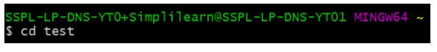
- Create a new git instance for a project.
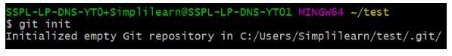
- Create a text file called info.txt in the test folder; write something and save it.
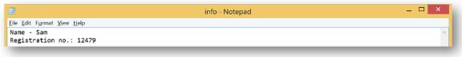
- Check the status of the repository.
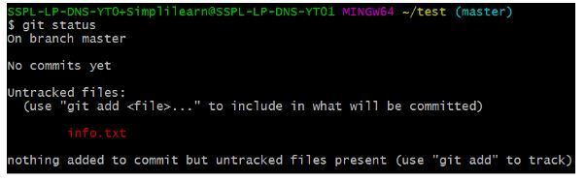
- Add the file you created to make a commit.
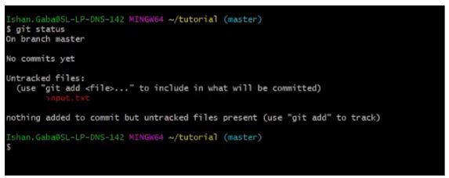
- Commit those changes to the repository’s history with a short message.
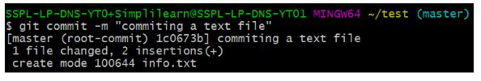

Free Course: Introduction to DevOps Tools
Master the Fundamentals of DevOps ToolsENROLL NOW
- Make any necessary changes to the file and save.
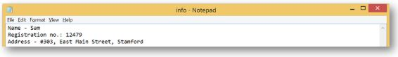
- Now that you’ve made changes to the file, you can compare the differences since your last commit.
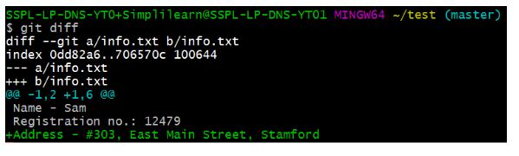
- Add GitHub username to Git Configuration.
- Create a remote repository.
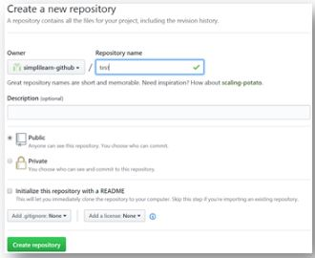
- Connect the local repository to your remote repository.
- Push the file to the remote repository.
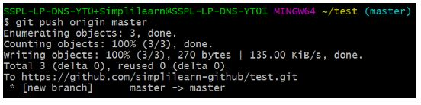

DevOps Engineer Master's Program
Bridge between software developers and operationsEXPLORE COURSE

- Refresh your repository page on GitHub. You will get your local file on your remote GitHub repository.
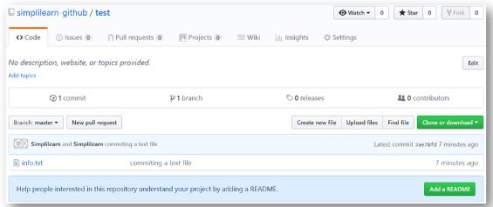
- Create three more text files in the local repository - “info1.txt”, “info2.txt”, “info3.txt”.
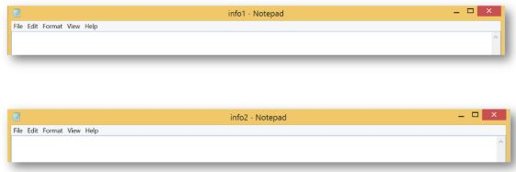
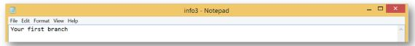
- Create a branch “first_branch” and merge it to the main (master) branch.
The above command creates a branch.
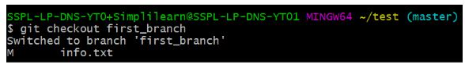
The above command switches to the new branch from the master branch.
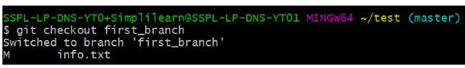
The above command creates and adds “info3.txt” to the first_branch.

FREE DevOps Certification Training
Master in-demand DevOps tools and skillsENROLL FOR FREE

- Create a branch “first_branch” and merge it with the main (master) branch.
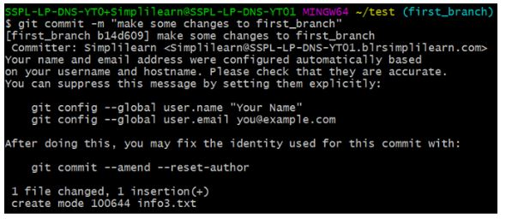
The above command makes a commit to the first_branch.
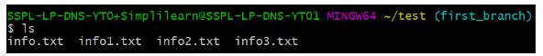
The above command shows that the new branch has access to all the files.
The above command shows that the master branch does not have an “info3.txt” file.
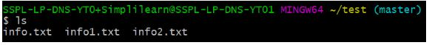
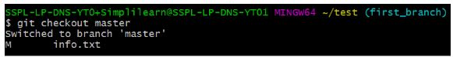
The above command is used to merge “first_branch” with the master branch. Now, the master branch has “info3.txt” file.
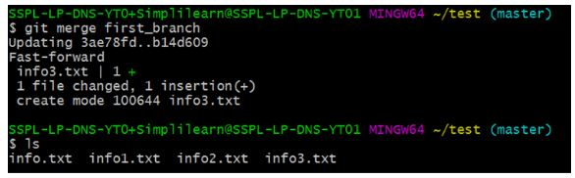

What is DevOps?
DevOps is a culture that allows the development and operations teams to work together. With this type of working environment, developers continuously develop and test codes, and there is continuous integration taking place throughout the lifecycle. The operations team continuously deploys the code to the production environment. DevOps allows for better collaboration, increased trust, and faster software releases.
